Mid-Term Question Paper

(Submission in 10 days from Today (23rd Sep 2018) i.e on 3rd Oct 2018)) Max Marks : 40 (10 x 4)

1. **Use images in Garden_Forests folder. Use 6 images of each class for training, and the remaining for testing. Classify the test images using SVM ( kernel of your choice)**

**Use the following classes of features**

1. **Color Histogram**
2. **SIFT**
3. **Bag of Words**

**For each case, tabulate (i) Confusion Matrix**

**(ii) ROC curves**

**What do you infer ?**

1. **Is the performance not optimal ? Why ?**
2. **Which class of features is best suited ?**
3. **What change needs to be incorporated to improve the performance ?**

ANSWER :

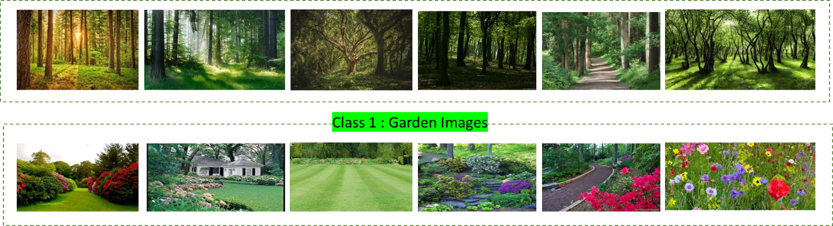

**Figure 1. Training Dataset**

**Color Histogram**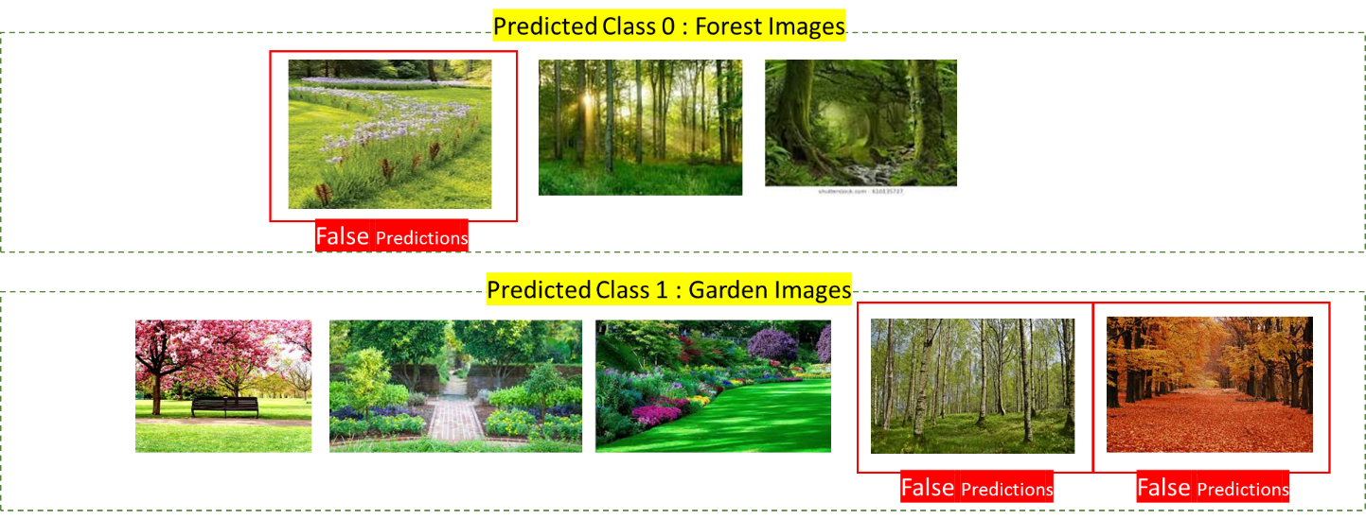

**Figure 2. Predictions using SVM with Color Histogram**

**Table 1. Confusion Matrix**

|  |  |  |
| --- | --- | --- |
| N=8 | Predicted = 0 | Predicted = 1 |
| Actual = 0 | 2 | 2 |
| Actual = 1 | 1 | 3 |

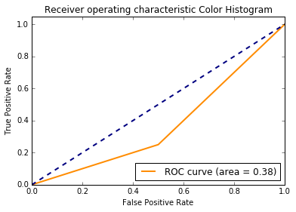

**Figure 3. ROC Curve**

**BAG OF WORDS**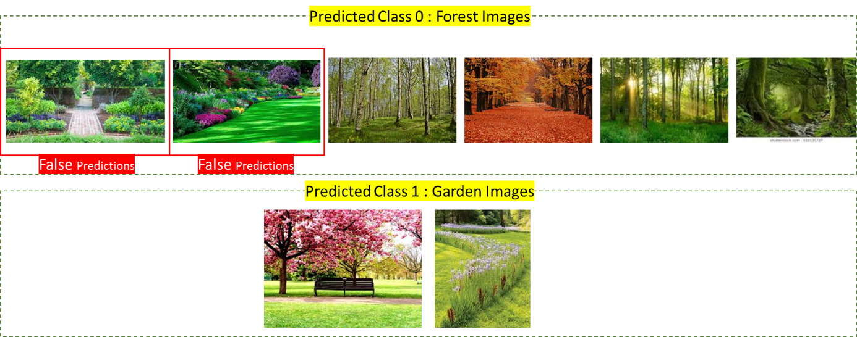

**Figure 4. Prediction using SVM with BoW.**

**Table 2. Confusion Matrix**

|  |  |  |
| --- | --- | --- |
| N=8 | Predicted = 0 | Predicted = 1 |
| Actual = 0 | 4 | 0 |
| Actual = 1 | 2 | 2 |

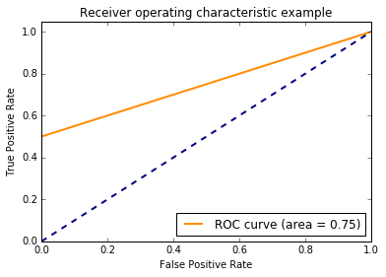

**Figure 5. ROC Curve**

**SIFT**

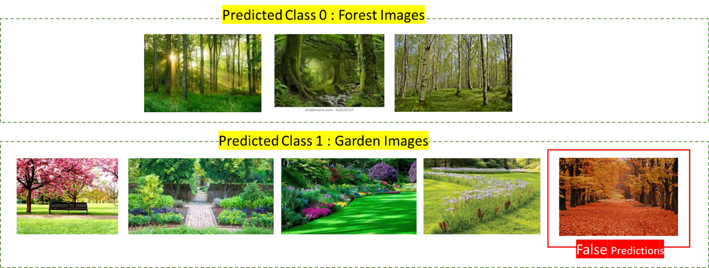

**Figure 6. Predictions using SVM with SIFT features**

**Table 3. Confusion Matrix**

|  |  |  |
| --- | --- | --- |
| N=8 | Predicted = 0 | Predicted = 1 |
| Actual = 0 | 3 | 1 |
| Actual = 1 | 0 | 4 |

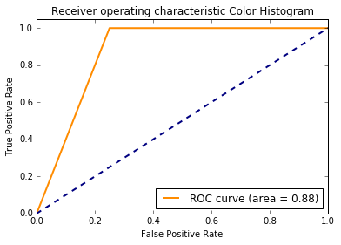

**Figure 7.ROC Curve**

1. The performance is not optimal because all of the above SVM classifier with Color histogram, BoW and SIFT features miss classify some images. The nearest to optimal will be the SIFT SVM but even that has some flaws.
2. As mentioned in the above point, the SIFT feature based SVM classifier works best for our dataset with the best results in terms of Confusion matrix and ROC curve (0.88). This is because SIFT features are in variant to rotation and scale in contrast to the BoW. Furthermore, SIFT descriptors are more detailed and stable than simple color histogram.
3. To better the performance firstly, the amount of training data should be increased significantly. The classifier should be able to train on enough varied examples to generalize better. In our case the orange forest image of fall is wrongly classified by SIFT and color histogram based SVM classifiers primarily because the classifier did not train on any forest image of that color tone. Additionally, complex kernel would also help our case a lot.
4. **Use images in Indoor_Outdoor folder. Use Indoor images to create a dictionary for sparse representation using SPAMS toolbox. Choose Hyperparameters appropriately. Call this Dictionary Indoor_Dict. Now repeat the procedure for the Outdoor images. Call it Outdoor_Dict.**
5. **What differences do you notice between Indoor_Dict and Outdoor_Dict ?**

**Reconstruction :**

1. **Obtain image reconstruction of an Indoor image using Indoor _Dict, call it IN_IN. Now obtain image reconstruction of the same Indoor image using Outdoor_Dict. call it IN_OUT**
2. **Obtain image reconstruction of an Outdoor image using Indoor _Dict, call it OUT_IN. Now obtain image reconstruction of the same Outdoor image using Outdoor_Dict. call it OUT_OUT**

**What are your Observations ?**

1. **Read the Abstract and Conclusion of your chosen paper (Project paper) carefully. If you were to extend one specific aspect of the paper, what would it be ? Why ? Substantiate with a road-map.**
2. **Create a 5 – level Gaussian pyramid of the image given Gaussian_pyramid folder. What can you say about the image contents by thresholding at each level ? Now re-do the same exercise using Laplacian pyramid. What do you observe ?**

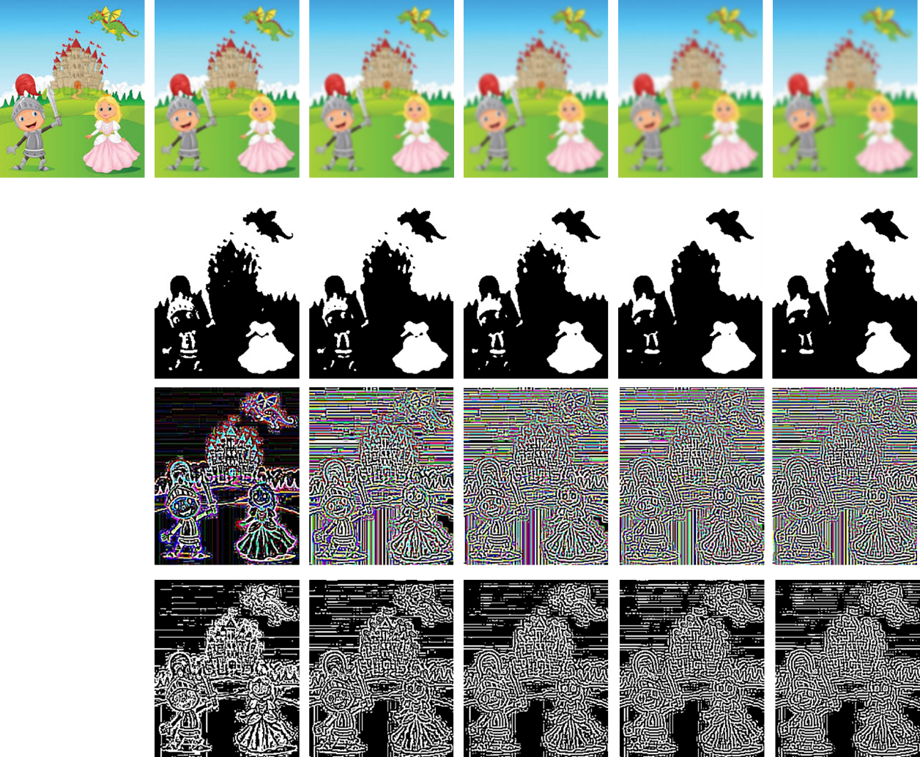

**Figure 5. Image pyramids: 1st Row Guassian Image Pyramid, 2nd Row - OTSU thresholded results of Row 1, Row 3 - Laplacian Pyramid, Row 4 - OTSU thresholding of Row 3**

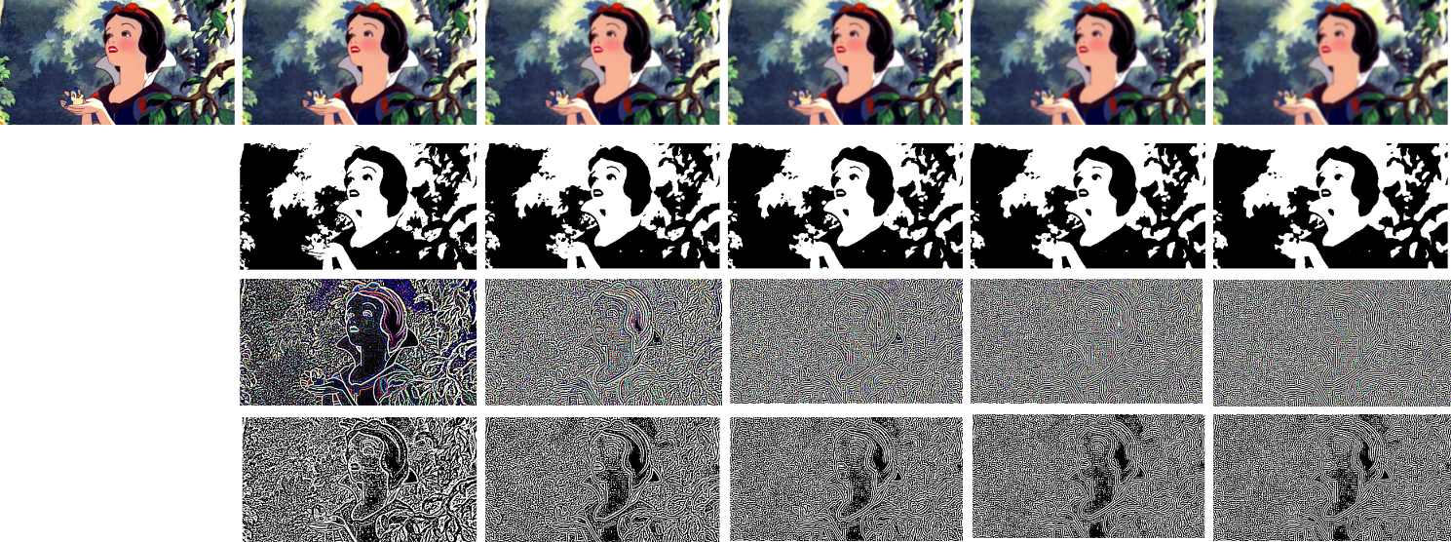

**Figure 6. Image pyramids: 1st Row Guassian Image Pyramid, 2nd Row - OTSU thresholded results of Row 1, Row 3 - Laplacian Pyramid, Row 4 - OTSU thresholding of Row 3**

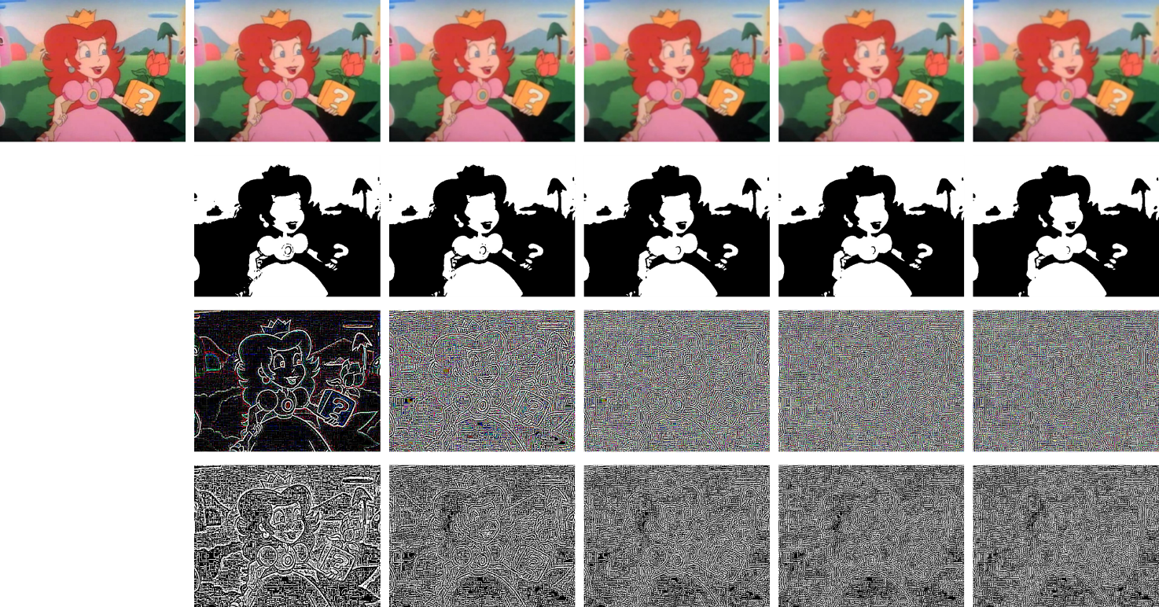

**Figure 7. Image pyramids: 1st Row Guassian Image Pyramid, 2nd Row - OTSU thresholded results of Row 1, Row 3 - Laplacian Pyramid, Row 4 - OTSU thresholding of Row 3**

The thresholding results on the Gaussian Image pyramid loses details (marked in red) with increasing coarseness. The fine details and edges are smoothed out with coarseness and number of zero crosses significantly. Isolated segments are also reduced from the images of higher coarseness in the gaussian pyramid (marked with yellow) and only significantly large details remain till the last image of the pyramid.

Where in the case of Laplacian pyramid, the number of zero crossing increases with each level of the pyramid. With increasing number of edges the amount of noises also increase and important details are crowded by unimportant edges. This has the exact opposite effect of the Gaussian pyramid.